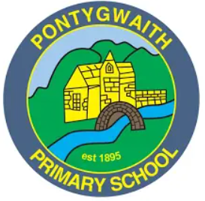

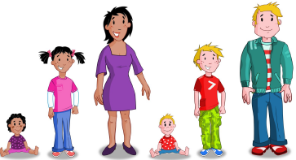

Personal Development and Relationships

Information booklet for parents

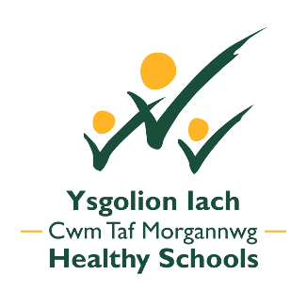

The purpose of this leaflet is to provide you with information on our Personal Development and Relationships programme.

Our Personal Development and Relationships lesson plans have been developed to support the delivery of high quality healthy relationships education. The knowledge and skills pupils in Foundation Phase and Key Stage 2 will gain from this series of lessons will help to build their resilience, confidence and self-esteem to empower them to develop and maintain healthy relationships as they move through childhood into adolescence.
Personal Development and Relationships education is a term used to describe the range of learning experiences and support that schools provide for pupils to develop safe, respectful personal relationships. This includes taking responsibility for their behaviour in their personal relationships, how to recognise inappropriate behaviour, keep themselves safe and the changes that will happen to their body as they grow up.
Our Personal Development and Relationships programme and teaching have been informed by;
- Welsh Government Sex and Relationships Education in Schools guidance (2010)
- The Personal and Social Education Framework for 7-19-year-olds in Wales
- Foundation Phase, Personal and Social Development, Well-being and Cultural Diversity area of learning

We will be using a series of lessons plans which have been developed and agreed by a team of primary schools in Cwm Taf to deliver high quality personal development and relationships education.


Pupils will learn about Personal Development and Relationships through: annotate as necessary
- The Cwm Taf Healthy Schools Scheme lesson plans
- The Gwynedd Healthy School Scheme ‘Growing Up/ Tyfu i Fyny’ teaching resources
- The ‘Sense- Growing Up and Keeping Safe’ CD
- The NSPCC ‘PANTS Underwear Rule’, resources and Pantosaurus cartoon
- School Beat website
- Circle time activities. This is when we might talk about growing up while sitting in a circle with other classmates
- Sessions with the School Nurse
- Story books.

Learning Outcomes for Nursery, Reception, Year 1 & Year 2 Pupils (Foundation Phase)

Education about personal development and relationships in the Foundation Phase will focus on the building of self-esteem by encouraging learners to value themselves, recognise and communicate their feelings and form friendships and relationships.

By the end of year 2 pupils should be able to:

- Recognise what qualities make a good friend
- Know how to keep clean and look after their bodies
- Express & communicate different feelings
- Use the correct anatomical names for parts of the body in order to tell the difference between male and female
- Tell the difference between appropriate and inappropriate touching.

Learning Outcomes for Years 3 and 4

By the end of year 3 and 4 pupils should be able to:

- Understand the importance of keeping themselves safe and know the difference between appropriate and inappropriate touching
- Understand what to do or to whom to go when feeling unsafe
- Understand the concept of being safe online
- Take increasing responsibility for keeping the mind and body safe and healthy
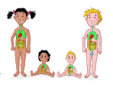
- Value families and friends as a source of mutual support
- Develop respect for themselves and others
- Understand how cultural and religious beliefs can affect the way people think
- Respect differences and acknowledge the importance of equal opportunities
- Recognise the different types of bullying
- Value different types of families

Learning Outcomes for Years 5 and 6

By the end of year 5 and / or year 6 pupils should:

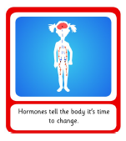
- Know the names, positions, functions and relative sizes of the human’s
main organs
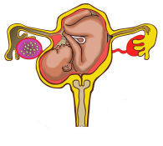
- Understand the reasons for the physical and emotional changes which
take place during puberty
- Understand how babies are conceived
- Know how a baby develops during pregnancy and how it is born
- Understand the range of their own and others’ feelings and
emotions
- Know what to do or who to turn to when they are not feeling safe.

If you wish to see the lessons in more detail, a copy of our school’s policy or view any of the resources please ask your child’s class teacher.

Useful links for parents:
Sex and Relationships Education in Schools (Welsh Government, 2010) http://learning.gov.wales/docs/learningwales/publications/130425-sex-and-relationships-education-in-schools-en.pdf

For a guide to talk to your child about the NSPCC Underwear Rule please follow this link: https://www.nspcc.org.uk/globalassets/documents/advice-and-info/underwear-rule-guide-for-parents.pdf

Family Planning Association, Parental Information Leaflets: How to talk to your child about Sex and Relationships Education http://www.publichealthnetwork.cymru/files/2614/4359/8957/Factsheet1_HowToTalkChildrenAboutSRE.pdf

SchoolBeat.org is a bilingual site from the All-Wales School Liaison Core Programme, providing information and resources for teachers, pupils and parents to follow up on the lessons provided to primary and secondary school children by our School Community Police Officers. The website focuses on the three main themes of the Programme: drug and substance misuse, social behaviour and community and personal safety
https://www.schoolbeat.org/en/pupils/

This leaflet has been designed with kind permission from the Gwynedd Healthy Schools Scheme.

